# HYBRID RENEWABLE ENERGY SYSTEM BASED WATER PUMPING SYSTEM

An Undergraduate CAPSTONE Project By

|  |  |  |
| --- | --- | --- |
| 1. Rashid, Mahnaz | ID: 16-32679-3 | Dept: EEE |
| 2. Salma, Sheikh | ID: 16-32754-3 | Dept: EEE |
| 3. Azmain, Adib | ID: 16-32632-3 | Dept: EEE |
| 4. Khan, Afiqul Haque | ID: 16-32640-3 | Dept: EEE |

Under the Supervision of

## Susmita Ghosh

Assistant Professor

# Fall Semester 2019-2020,

**December, 2019**



**Faculty of Engineering**

**American International University - Bangladesh**

**HYBRID RENEWABLE ENERGY SYSTEM BASED WATER PUMPING SYSTEM**

A CAPSTONE Project submitted to the Faculty of Engineering, American International University - Bangladesh (AIUB) in partial fulfillment of the requirements for the degree of Bachelor of Science in their mentioned respective programs.

|  |  |  |
| --- | --- | --- |
| 1. Rashid, Mahnaz | ID: 16-32679-3 | Dept: EEE |
| 2. Salma, Sheikh | ID: 16-32754-3 | Dept: EEE |
| 3. Azmain, Adib | ID: 16-32632-3 | Dept: EEE |
| 4. Khan, Afiqul Haque | ID: 16-32640-3 | Dept: EEE |

**Fall Semester 2019-2020,**

**December, 2019**

# Faculty of Engineering

**American International University - Bangladesh**

DECLARATION

This is to certify that this project is our original work. No part of this work has been submitted elsewhere partially or fully for the award of any other degree or diploma. Any material reproduced in this project has been properly acknowledged.

AIUB reserves the right to reuse/update any proprietary material designed and developed for this work.

Students’ names & Signatures

1. **Rashid, Mahnaz**

_ _ _ _ _ _ _ _ _ _ _ _ _ _ _ _ _ _ _

### Salma, Sheikh

_ _ _ _ _ _ _ _ _ _ _ _ _ _ _ _ _ _ _ _

### Azmain, Adib

_ _ _ _ _ _ _ _ _ _ _ _ _ _ _ _ _ _ _ _

### Khan, Afiqul Haque

_ _ _ _ _ _ _ _ _ _ _ _ _ _ _ _ _ _ _ _

APPROVAL

The CAPSTONE Project titled Hybrid Renewable Energy System Based Water Pumping System has been submitted to the following respected members of the Board of Examiners of the Faculty of Engineering in partial fulfillment of the requirements for the degree of Bachelor of Science in the respective programs mentioned below on **December, 2019** by the following students and has been accepted as satisfactory.

|  |  |  |
| --- | --- | --- |
| 1. Rashid, Mahnaz | ID: 16-32679-3 | Dept: EEE |
| 2. Salma, Sheikh | ID: 16-32754-3 | Dept: EEE |
| 3. Azmain, Adib | ID: 16-32632-3 | Dept: EEE |
| 4. Khan, Afiqul Haque | ID: 16-32640-3 | Dept: EEE |

_ _ _ _ _ _ _ _ _ _ _ _ _ _ _ _ _ _ Supervisor

[Ms. Susmita Ghosh]

Assistant Professor

Faculty of Engineering

American International University- Bangladesh

_ _ _ _ _ _ _ _ _ _ _ _ _ _ _ _ External Supervisor

[S.M. Imrat Rahman]

Senior Lecturer

Faculty of Engineering

American International University- Bangladesh

_ _ _ _ _ _ _ _ _ _ _ _ _ _ _ _ _ _ Prof. Dr. Md. Abdur Rahman Associate Dean

Faculty of Engineering

American International University- Bangladesh

_ _ _ _ _ _ _ _ _ _ _ _ _ _ _ _ _ _ Prof. Dr. ABM Siddique Hossain Dean

Faculty of Engineering

American International University- Bangladesh

_ _ _ _ _ _ _ _ _ _ _ _ _ _ _ _ _ _ Dr. Carmen Z. Lamagna

Vice Chancellor

American International University-Bangladesh

ACKNOWLEDGEMENT

We want to thank all the people who have been helping and encouraging us through the whole project work.

Firstly, we want to thank our respectable project supervisor Ms. Susmita Ghosh, Assistant Professor, Faculty of Engineering, American International University-Bangladesh for her excellent guidance and help. Her faith made us more confident for doing this project. We also want to thank our external supervisor S.M. Imrat Rahman, Senior Lecturer, Faculty of Engineering, American International University-Bangladesh.

Secondly, we want to show our gratitude to Dr. Carmen Z. Lamanga, Vice Chancellor, American International University-Bangladesh for encouraging us. We would also like to thank Prof. ABM Siddique Hossain, Dean, Faculty of Engineering, American International University-Bangladesh and we also want to thank Prof. Dr. Md. Abdur Rahman, Associate Dean, Faculty of Engineering, American International University-Bangladesh.

We are very grateful to our parents for understanding and supporting our project. We also want to thank our teachers, friends and staff members of our department. We also want to thank those people who helped us while doing survey.

Finally, we want to thank Almighty for all the blessings and strength he has given to us.

* 1. Rashid, Mahnaz
  2. Salma, Sheikh
  3. Azmain, Adib
  4. Khan, Afiqul Haque

# TABLE OF CONTENTS

ABSTRACT 10

Chapter 1 11

**INTRODUCTION 11**

1.1. Overture 11

1.2. Historical background 11

1.3. Objective of this work 11

1.4. Comparison with traditional method 12

1.5. Impact of project on society 12

1.6. Project management 13

1.7. State of the art technology 13

1.8. Introduction of the project 13

Chapter 2 15

**Literature Review 15**

2.1. Introduction 15

2.2. Demand of renewable energy 15

2.3. Wind power 15

2.3.1. Types of wind turbine 16

2.3.2. Horizontal axis wind turbine 17

2.3.3. Vertical axis wind turbine 17

2.4. Solar power 18

2.5. Hybrid renewable energy system (HRES) 19

2.6. Utilization of wind and solar power to generate HRES 20

2.7. History of water pumping system 21

2.8. HRES based water pumping system 21

2.9. Summary 21

Chapter 3 22

**METHODOLOGY AND MODELING 22**

3.1. Introduction 22

3.2. Methodological approach 22

3.3. Methods of data collection 24

3.3.1. Survey Conduction 24

3.3.2. Questionnaire 24

3.3.2.1. Questionnaire composition 24

3.3.2.2. Guideline for selection of effective questions 24

3.3.2.3. Order of question 24

3.3.3. Mode of survey 24

3.3.4. Response of interviewers 24

3.4. Experiments 25

3.5. Flow chart 25

3.6. Methods of analysis 26

3.6.1. Outline of the project idea 26

3.6.2. Software used for analyzing the data 26

3.6.3. Methods used to accomplish the goal 26

3.7. Summary 27

Chapter 4 28

**IMPLEMENTATION OF PROJECT 28**

4.1. Introduction 28

4.2. Familiarization with equipment 28

4.2.1. Designed equipment 28

i. Vertical axis wind turbine (VAWT) 28

ii. Charge controller circuit 29

iii. DC water pumping system 29

4.2.2. Market purchased equipment 30

i. Solar panel or PV panel. 30

ii. Battery bank 31

4.3. Experimental setup (Hardware implementation) 31

4.3.1. Design prototype of wind turbine 31

4.3.2. Design prototype of charge controller 32

4.3.3. Design prototype of whole project 33

4.4. Simulation of charge controller circuit 33

4.5. Summary 34

Chapter 5 35

**RESULT ANALYSIS AND CRITICAL DESIGN REVIEW 35**

5.1. Introduction 35

5.2. Overall Outcome of the project 35

5.3. Outcome of designed wind turbine 36

5.4. Analysis of experimental wave shapes 37

5.5. Profound calculation of project output 40

5.6. Summary 40

Chapter 6 42

**CONCLUSION 42**

6.1. Summary of findings 42

6.2. Project finance 42

6.3. Novelty of the work 42

6.4. Final impact of this project 43

6.4.1. Survey on environmental impact 43

6.4.2. Project sustainability and future scopes 43

6.4.3. Recommendations on future developments 43

6.5. Limitation of the work 44

6.6. Ethical concerns 44

6.7. Conclusion 44

REFERENCES 45

Appendix A 47

**Survey Questionnaire 47**

# LIST OF FIGURES

Figure 1.1 Pie Chart 9

Figure 2.1 First Horizontal Wind Turbine (1888 In Cleveland, Ohio) 13

Figure 2.2 Different Types Of Wind Turbine 13

Figure 2.3 Horizontal Axis Wind Turbine (Hawt) 14

Figure 2.4 Savonius And Darrieus Vawt Wind Turbine 15

Figure 2.5 Solar Panel 15

Figure 2.6 First Solar Panels (1955) 16

Figure 2.7 Wind-Solar Hybrid System 17

Figure 3.1 Flowchart 20

Figure 3.2 Block Diagram Of Wind-Solar Hybrid Water Pump 22

Figure 3.3 Flowchart Of Hybrid Renewable Water Pumping System 23

Figure 4.1 Vawt 26

Figure 4.2 Charge Controller Circuit 26

Figure 4.3 Dc Water Pump 27

Figure 4.4 Solar Panel 27

Figure 4.5 Battery Bank 28

Figure 4.6 Prototype Design Of A Vertical Axis Turbine (Vawt) 29

Figure 4.7 Prototype Design Of A Charge Controller 30

Figure 4.8 Prototype Design Of Whole Project 31

Figure 4.9 Circuit Diagram Of Charge Controller 32

Figure 5.1 Prototype Design Of The Whole Project 33

Figure 5.2 Vertical Axis Wind Turbine 34

Figure 5.3 Battery Charging Time Of First Day By Using Solar Panel (While Battery Is Being Discharged Deeply) 35

Figure 5.4: Battery Charging Time Of Second Day By Using Solar Panel (While Battery Is Being Discharged Deeply) 36

Figure 5.5 Battery Charging Time Battery Of First Day By Using Wind Turbine (When Battery Was Not Deeply Discharged) 36

Figure 5.6 Battery Charging Time Battery Of Second Day By Using Wind Turbine (When Battery Was Not Deeply Discharged) 37

Figure 5.7 Charging Battery By Using Both Solar Panel And Wind Turbine (First Day) 37

Figure 5.8 Charging Battery By Using Both Solar Panel And Wind Turbine (Second Day) 38

Figure 6.1 Pie Chart Of Environmental Effect 40

# LIST OF TABLES

Table 4.1 Familiarization with equipment 25

Table 5.1 Initial stage without gearbox 34

Table 5.2 Initial stage with gearbox 35

Table 6.1 Project finance 39

ABSTRACT

Hybrid energy is a type of energy source where two or more renewable energy system is used to produce energy. The name of the project is Hybrid Renewable System Water Pumping System. In this project both wind turbine and solar panel has been used to generate power. The main purpose of this project is generating power through hybrid renewable system and running water pump using that power. This project is made to reduce the use of power from power grid. It is known that power grid produces huge amount of carbon dioxide. They use fossil fuels which is very dangerous for environment because burning of fuels create huge amount of carbon dioxide. Also generation of power through this process takes less time because both wind turbine and solar panel works together to generate power. The goal of this project was to make it both environment friendly and money saver at the same time. Rural areas of Bangladesh still don’t get enough power supply. So this system can be used in those places so that people in rural areas can get enough water. This project will produce a good amount of electricity which will be stored in a battery. When the water pump will be turned on the pump will take power from the battery. This project will be used in a huge amount in future. This project can be made more useful in future by making the design more simple and implementation of the project easier.

Chapter 1

INTRODUCTION

* 1. Overture

Water pump is a mechanical device which is used to get water from water source. Water pump is being used all over the year to get water for agricultural, industrial, household use, factories etc. Almost in every house both in urban and rural area water pump will be found which is used to get water for various works. But Bangladesh has energy crisis and rural areas get 30% [16] of electricity which is not enough. Also running water pump using power from power grid is quite expensive for the people living in rural areas. At the same time it is known that global warming is a great problem in the world. Power stations burn fossil fuels such as gas, oil, coal etc. It produces huge amount of carbon dioxide. This carbon dioxide can do great harm to the climate so using renewable energy can be a great solution to this. So that’s why a renewable energy based water pumping system is made. Here a water pump will work by the electricity which will be generated by vertical axis wind turbine and solar operated dc motor. In this project we have used both solar and wind power to generate energy. This will be both low at cost and environmental friendly at the same time [1]

* 1. Historical background

Wind-solar hybrid system was found in 20th century in China. The main target of using hybrid system was to reduce electricity cost. It was first seen on the street lights of Weihai, Shandong, China. It was also seen in some buildings in 2003 in China. Hybrid system is still not very popular but it will be popular very soon. Nowadays hybrid system is being used in many buildings, factories, houses etc. as source of producing electricity. Wind-solar hybrid water pump is being used in many farms all over the world. But wind-solar hybrid water pump is not popular for household works. It is very rare.

* 1. Objective of this work

This project has been chosen focusing one prime objective which is to produce electricity in an eco- friendly way that will do no harm to the environment and at the same time will be cost effective. The objective of this project is to run water pump using hybrid renewable system. Water pump is a mechanical system which is used to take water from ground. Hybrid renewable system is being used in this project to run water pump. This project is using both wind turbine and solar panel to produce electricity. So that’s why this project is more environments friendly.

* 1. Comparison with traditional method

In present days, water pump is run by electricity which comes from power grid. It is quite expensive for people living in rural areas. Grid driven water pump is harmful for environment because it emits various gases by combustion of fossil energy sources. It can relate to climate change and health hazards.

On the other hand in hybrid water pumping system, electricity is produced by using wind turbine and solar panel. They both take energy from nature and also do not emit dangerous gas to nature. This project is easy to use because it uses energy from natural resources and it is not costly.

* 1. Impact of project on society

This project will have a great impact on the society. The impact of this project may have good or bad result. So we did a survey on people to generate a survey data.

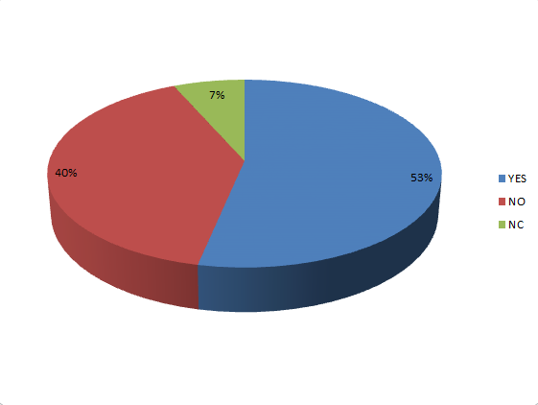

Figure 1.1 Pie chart

Based on the survey, 30 people were surveyed to get feedback about our project where 53% people appreciated our proposed system. Our project got appreciation because according to these 53% people, our project is appropriate for society to fight global warming. Other 40% people could not find it appropriate for our society considering cost, implementation & maintenance. Rest 7% people could not give any feedback as they could not realize the importance of this project.

* 1. Project management

The project was organized by routine steps which were done by specific time. The date of orientation was 26th of May 2019. Firstly, we selected our project topic and title in between 26th May to 12th June. After that, the proposal was submitted on 13th June. Then first two chapter of book were done from 5th July to 17th August. Hardware research and collection were also done in 27th June. After that we prepared the progress report and attended to present the initial progress of the project in the progress defense on 15th August to 25th August. Afterwards, upgrades of the implementation of these projects were done in between 15th September to 25th September. Later the thesis book and the testing of the device were completed on 28th November to 12th December. Then necessary updates of the device and submission of the thesis book to external were done by the following days. Finally, attended the final defense on 24th December.

* 1. State of the art technology

Currently renewable energy like hydropower, wind, solar, etc. is mainstream. Hybrid renewable energy is not that old invention. There are so many types of hybrid renewable systems available. Nowadays renewable energy is a great alternative to power grid power. Renewable energy doesn’t emit carbon dioxide which is very harmful for the environment and also saves so much money. Installation of a renewable energy source can be little expensive but after that one doesn’t need to pay for anything.

Almost every developed country now produces half of their electricity using renewable energy source. Bangladesh is a developing country. Still this country doesn’t have any renewable energy based power station but the government’s aim is to generate at least 10% [17] of power using renewable power source by 2020. So it is assumed that soon Bangladesh will have renewable energy based power station. As seen that renewable energy is very popular right now so it is assumed that in future almost every countries maximum power station will depend on renewable energy producing system.

* 1. Introduction of the project
* Chapter 1

In this chapter we introduced our project. By inspecting some journals and some past events of this type of research is established on this chapter. Also some information about earlier and present research is given. The main objective and abridgement of our projects were also described in this chapter**.**

* Chapter 2

This chapter is based on literature review with in-depth investigation and description about the features of the materials used in this project.

* Chapter 3

This chapter is based on how this project is going to be implemented, i.e. methodology and description about the equipment’s used in the project.

* Chapter 4

Main part of this chapter is working procedure of the whole project and the hardware implementation with necessary figure and diagram of this project are shown.

* Chapter 5

The simulation part and circuit design are shown in this chapter. A software implementation has been done and analysis after developing basic concept.

* Chapter 6

This chapter includes discussion and conclusion along with the environmental impact of this project and future recommendation to upgrade the project is also included.

Chapter 2

Literature Review

* 1. Introduction

In this project, a water pumping system using hybrid renewable energy system has been designed. In this project solar-wind hybrid system is being used to generate power to run water pump. It is expected that this project will be both economically and environmentally effective both in urban and rural areas. This chapter represents the background study and literature review which has been done by the group members in choosing the project topic and selecting the hardware design of the project.

* 1. Demand of renewable energy

Demand of renewable energy is increasing day by day. It is known that renewable energy means energy which is produced by natural resources like wind, water, solar, tides, waves etc. We find these everywhere around the world easily and it’s also free. Renewable energy is being used in a large scale nowadays. Renewable energies demand is high because the resources are easy to find and it’s not harmful for the environment. Renewable energy is being used all over the world now. It is seen in big factories, houses, roads, offices, farms etc. places.

Power stations use fossil fuels such as coal, gas etc. to produce electricity. These fossil fuels also produce a huge amount of carbon dioxide while producing electricity. The produced carbon dioxide is very harmful for the environment because it plays an important role in greenhouse effect. In this age greenhouse effect is a very serious problem which has to be reduced as soon as possible. So to control greenhouse effect we have to stop using fossil fuels to produce electricity and we have to start using renewable power producing sources. Renewable energy sources do not do any harm to the environment and also does not emit carbon dioxide to the environment. So renewable energy can be a great alternative to fossil fuels.

* 1. Wind power

Wind power is basically generated by pressure of air which helps a fan to rotate. And the fan helps the generator to produce electricity. The fans are called turbine. Wind turbine is a very common thing to produce electricity nowadays. We see this everywhere all around the world and also in Bangladesh. The first wind turbine was made in 1888 in Cleveland, Ohio by Charles F. Brush which was a horizontal wind turbine [1]. In early 5000 BC to 200 BC people used to use wind to propel boats. In early 1800s to 1900s American colonists used windmill for grinding, water pumping and to cut wood [15].

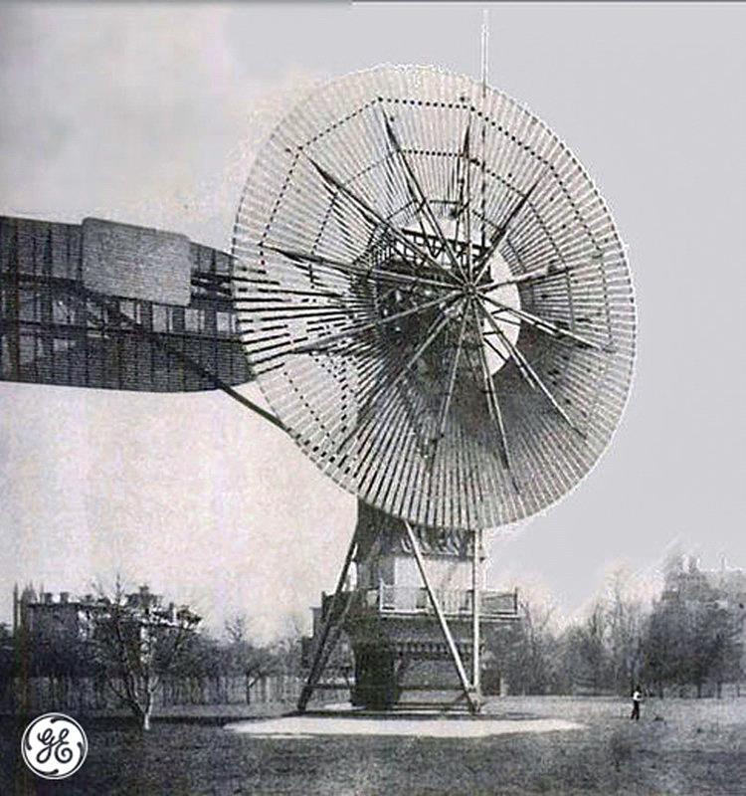

Figure 2.1 First horizontal wind turbine (1888 in Cleveland, Ohio) [1]

* + 1. Types of wind turbine

There are two types of wind turbine-

* + - * Horizontal axis wind turbine (HWAT)
      * Vertical axis wind turbine (VAWT)

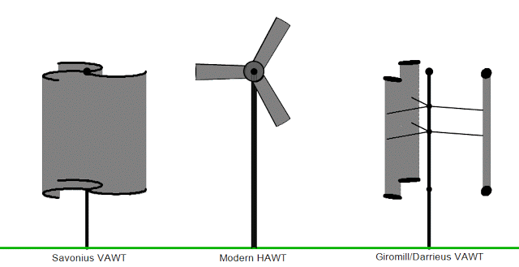

Figure 2.2 Different types of wind turbine [2]

* + 1. Horizontal axis wind turbine

Horizontal axis wind turbine is a type of turbine where the fans of the turbine are attached horizontally. The propeller is the most important part of a horizontal wind turbine. A generator is attached on the top of the tower and there is also a propeller or a wind sensor to detect wind for the wind turbine. First horizontal wind turbine was made in 1888 by Charles Babush in Ohio. The design of horizontal wind turbine is getting developed day by day.

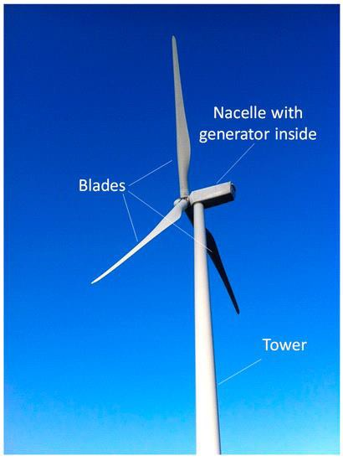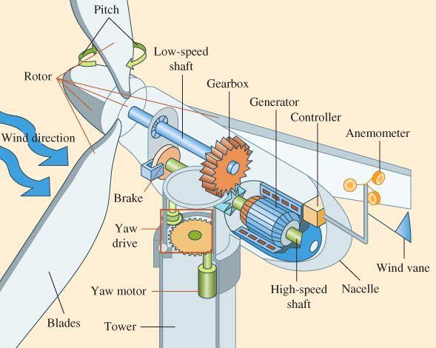

Figure 2.3 Horizontal axis wind turbine (HAWT) [3] [4]

* + 1. Vertical axis wind turbine

In this type of turbine the blades are set vertically and the generator is set under the turbine. This turbine stands on the top of the tower. The blades get hit by the wind in different angles. These kinds of turbines are more efficient for so many reasons but they are still not used in a large number. The first vertical axis wind turbine was found in Western Europe back in 1300-1875 A.D. There are two types of VAWT:

* Savonius
* Darrieus

Block diagram and flow chart formation

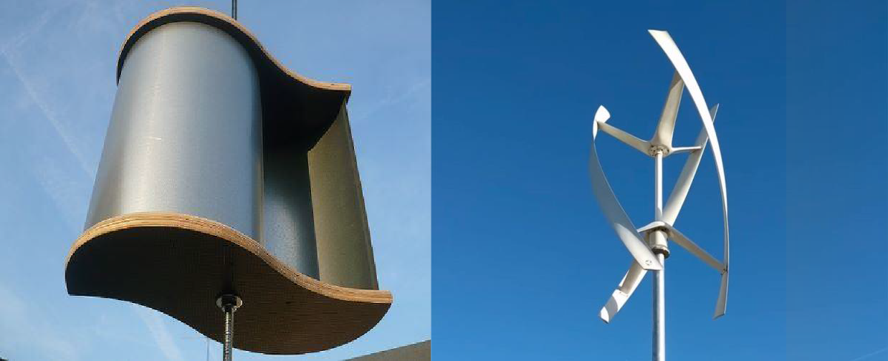

Figure 2.4 Savonius and Darrieus VAWT wind turbine [5] [6]

* 1. Solar power

Solar power is a type of power which is generated by sunlight and converted into electricity. The earth gets a lot of solar power. Solar panels are made of solar cells which are made of crystalline silicon. When the photons of the sun strike the silicon cell it moves electron of the cell and that's how electricity is produced. We can store solar power generated electricity and use it when it's needed. Solar power is very common everywhere around the world now. Some countries are using solar power to give electricity in whole area. It is also seen in houses, factories, farms etc. places in every country. The first ever solar panel was invented in 1954 by Bell Labs and it was a silicon solar cell [13]. In 1956 Keonjian and James O' Hearn invented a pocket sized solar powered radio. This can run for 500 hours without recharging [13].

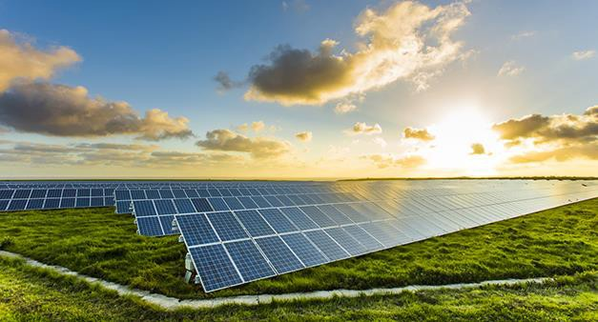

Figure 2.5 Solar panel [7]

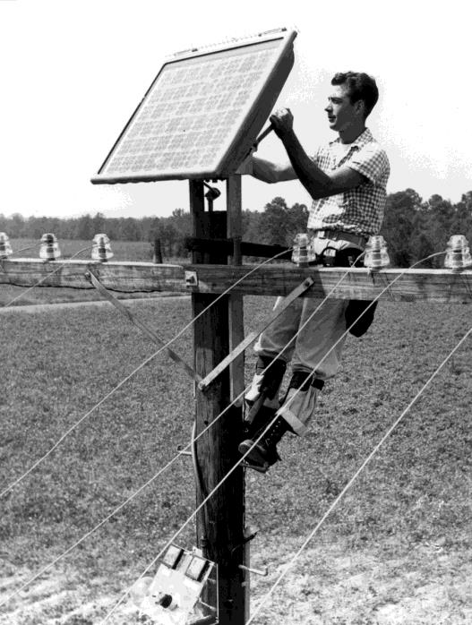

Figure 2.6 First solar panels (1955) [14]

* 1. Hybrid renewable energy system (HRES)

When energy is produced by using two or more renewable energy sources together then that is called hybrid renewable energy. In these types of energy producing systems both energy renewable energy sources work as a team to produce electricity. The amount of producing electricity through this process can be little higher that using single renewable energy source. Hybrid renewable energy can be used in places where climate changes very often. When a single renewable energy source is used fossil fuel is also used as emergency use that means if the system stops working properly fossil fuels will take their place and produce electricity. This process can also be harmful for the environment. To reduce the use of fossil fuels hybrid renewable energy can play an important role there. There are many types of hybrid renewable energy available:

* Biomass-wind
* Solar-wind
* Hydro-wind
* Solar-biomass
* Completely renewable
  1. Utilization of wind and solar power to generate HRES

Wind-solar hybrid system is a type of hybrid system where both wind and solar power is used to generate electricity. It can generate more power than using only one of them. When both systems are used the process becomes more reliable. In this process both wind and solar system works as a team. If the weather is little cloudy there is no way to get a good amount of sunlight so at that time wind turbine will do its job and produce electricity. On the other hand if one day the weather isn’t windy but there is a good amount of sunlight is out at that time solar panel will do the whole job and generate a good amount of electricity. If both of them work at the same time power generation will be faster than normal generation time. This system can be little costly but very effective. There are so many places where wind-solar hybrid system is being used to generate electricity as example in street lights, farms, buildings, ships etc. It was first seen used in street lights. USA’s first ever wind-solar hybrid power plant was in rural Minnesota. According to report it is said that hybrid solar-wind power system could reach $1.47 billion by 2024 [10]. Some people used solar-wind hybrid system to run boat. Some Middle Eastern countries like Egypt, Saudi Arabia etc. using hybrid renewable system in power stations. Saudi Arabia’s aim is to develop wind-solar hybrid system in next 10 years. They want to produce 10% of their power using renewable system by 2023.

They’re planning to produce almost 10 (GW) power by 2023 [9]. There is no date given for this project but they are working on this project right now. Egypt also has solar-wind hybrid power system in their country. Juwi a German project developer installed it in Egypt. This is used for irrigation and desalinating [11].

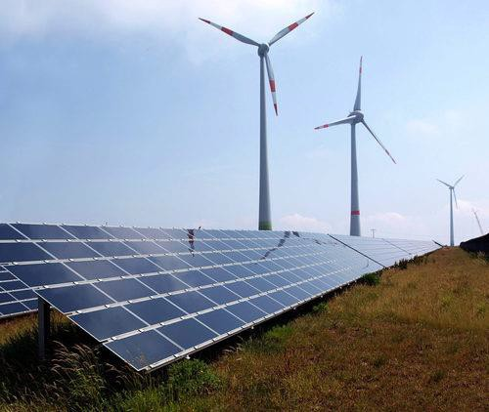

Figure 2.7 Wind-solar hybrid system [8]

* 1. History of water pumping system

Water pump is a machine which is used to collect water from the ground. People in the past used to get water from well which is very hard and also time consuming. The first water pump was made by Egyptians is 2000 BC. It is called shadoof. Shadoof is one kind of bucket attached with rod. It was used to take water from well, pond etc. After that in 200 BC Greek inventor and mathematician Ctesibius invented the water organ which is an air pump with valves on the bottom and a water tank in the middle of the way. This pump is also known as reciprocating pump. Also at that time Archimedes designed Archimedes screw pump. This is still called the greatest invention of all time and it is still used for pumping both liquid and solid in both type of industrial world. In 1475 the Brazilian soldier and historian of science Reti invented the first machine that can be called a centrifugal pump. It was used for mud lifting. In 1849 world’s first all-metal water pump was invented. In 1851 British inventor John introduced curved vane centrifugal pump. Day by day the design of water pump is developing and becoming more small and easy to install [12].

* 1. HRES based water pumping system

The project that we are making is called hybrid renewable energy system based water pumping system. In this project as the name we are using wind and solar power to generate electricity and run water pump using it. There are so many places where still electricity couldn’t reach as example rural areas, farms etc. For those places HRES based water pumping system can be a great idea. We know that this project already exists but we want to make our project for houses. So people in rural areas also in urban areas can get water easily in less cost. Installation of our project can be little expensive but after that electricity generation will be way easier. In our project hybrid system will only be used for pumping water.

* 1. Summary

As main goal of this project is to design a renewable energy based water pumping system, so it required a thorough study regarding renewable energy sources, advantages of renewable power generating system over traditional power generation, existing renewable energy source based water pumping systems and so on. This chapter is a reflection of all these background studies which are a kind of mandatory in order to make this project successful.

Chapter 3

METHODOLOGY AND MODELING

* 1. **Introduction**

The prime objective of this project is to design a water pumping system which will be in feed with renewable energy sources (wind and solar). In order to accomplish the prime objective of the project, successful design and implementation of a wind turbine has been utilized which can be considered as secondary objective of the project. This chapter focuses on the methodology of the whole project. In more detail, in this section the authors outline the organization and completion process of the project including survey conduction. In order to attain the project goals, hardware implementation is done which will be represented elaborately in chapter 4 and successful results are being shown in chapter 5. Although numerous pieces of previous project works have been completed which are similar to water pumping systems, this proposed project work has taken a form of new system based on the existing subject.

* 1. **Methodological approach**

The overall methodological approach of the respective project was a mixture of quantitative and qualitative approaches. Although it was not possible to undergo all the research methodologies but two of the very important parameters were accomplished. Firstly, people’s view and understanding towards the research idea was evaluated. Moreover, people were interviewed, and their opinions were gathered for the progression of the project work. Additionally, experiments are conducted under controlled variables and environments and the desired output of the experiments represent the zenith success of the project work. Figure 3.1 designates the flowchart of whole methodological approach oh the whole project work.

Project Proposal

Literature review of project work

Survey conduction on societal impact

System requirements and specification analysis

Electronic design of charge controller

Mechanical design of wind turbine

Building the prototype

System test

Satisfactory result

Survey conduction on environmental impact

Finalize the system

Project book completion and defending the project

No

Yes

Figure 3.1 Flowchart

* 1. Methods of data collection
     1. Survey Conduction

The survey was taken from a group of people on both societal and environmental impact of the project.

The survey was conducted on friends and relatives. The survey was taken from 30 people and some of them agreed and some of them disagreed with the project.

* + 1. Questionnaire
       1. **Questionnaire composition**

As the survey was on the topic environmental impact so the questions were built depending on environmental impact. They were asked if the project is suitable for the environment or not. The questions were made to get interviewers opinion on the project. 20 survey papers were printed and served to some friends and relatives. They ticked the answers and after that those papers were being collected.

* + - 1. **Guideline for selection of effective questions**

The survey questions were made using different thoughts. First of all it was thought that the project is really good for environment or not. Then Google’s help has also been taken. There were so many questions in Google. But there were some questions which were very suitable for the projects survey. After all 10 questions were finally selected for the project survey.

* + - 1. **Order of question**

The survey was written in a neat order. First question was if the project is good for the environment or not. After that if the project will emit any harmful gas and cause greenhouse effect. The goal was to take opinion from people on the project. People’s opinion does matter for a project. If maximum people of a survey do not like the project then the project will be a fail. So very simple but important questions were asked in the survey to get peoples opinion.

* + 1. Mode of survey

The survey was in-person interview type of survey. In this type of survey a sheet containing the survey questions was given to some people. They gave their opinion on the survey paper. The questions were containing questions on environmental impact of the project.

* + 1. Response of interviewers

Response of the interviewers was very positive. Maximum of them thought that the project can be very good for the environment. They thought the project can reduce greenhouse effect. They also said that they would love to implement the project if the project is made successfully. On the other hand some people did not think that the project can be useful for environment and they also said that they would not implement the project at their place if we make that successfully.

* 1. **Experiments**

In the block diagram on figure 3.2, the whole modeling of the project is being represented. First, there is a vertical axis wind turbine. Vertical axis wind turbine is a kind of turbine where the wings of the turbine are set vertically. A high speed vertical axis wind turbine using pipe, cycle rims, gear and much other stuff was made. This vertical axis wind turbine will rotate with the help of wind and it will also help the power generator to rotate. This process will produce electricity which will be stored after the process. Second, A PV panel was also taken. PV panel or solar panel basically absorbs solar energy and converts them into power. Third, a charge controller was used to limit current and send them to battery. MPPT charge controller was used for the project. Fourth, a 12v battery was used to store the power generated by the system. Fifth, with the battery an AC-DC inverter was connected. This inverter will convert AC power to DC power. This DC power will run the water pump which is used in the project. Sixth, with the inverter a water pump was attached. Water pump is a mechanical device which is basically used to get water from the ground. So water pump is being to get water for household and many other uses.

VAWT

Battery bank

DC water pump

Charge controller

PV panel

Figure 3.2 Block diagram of wind-solar hybrid water pump

* 1. **Flow chart**

Figure 3.3 illustrates the flow chart of hybrid renewable water pumping system. Given steps shows how the whole project works.

First, vertical axis wind turbine will rotate with the help of wind and it will rotate the generator which will produce electricity. At the same time PV panel will absorb solar power and convert it into electricity. Second, power from both wind turbine and solar panel will be sent to the charge controller. Charge controller limits current flow and sends limited power to the battery. Third, charge controller will send the limited charge to the battery and battery will store the power and use when it’s needed. Fourth, when the motor will be turned on AC power of the battery will go into the AC-DC inverter and AC power will be converted into DC power. This DC power will be used to run the pump.

Wind

Solar power

Wind turbine

PV panel

Charge controller

Battery bank

High speed DC water pump

Figure 3.3 Flowchart of hybrid renewable water pumping system

* 1. **Methods of analysis**
     1. Outline of the project idea

In this project a hybrid renewable water pumping system was made. Here wind turbine and solar panel has been used to produce electricity and run water pump using it. This project is very simple and cheap. This project can be used in rural and urban both areas. This project doesn’t take electricity from power grid so this is cheaper.

* + 1. Software used for analyzing the data

The whole project is hardware based. To design the charge controller Proteus was used. Proteus is software which is used for electrical design. It is used to make design of an electronic device and it also shows output voltage, current etc. All the important components are given in this software. One can design their electronic device in the software and see it will work or not. They will also find output of the project and also wave shape.

* + 1. Methods used to accomplish the goal

The main goal of this project was to make a water pumping system which is both environmental friendly and cheap at the same time. The methods that have been used to accomplish the goal are given below:

* Wind turbine has been used which doesn’t need any electricity from power grid.
* PV panel has also been used in this project which produces electricity by using solar power.
* No fuel or gas has been used and that’s why this project is very environmental friendly. Because it doesn’t emit carbon dioxide to the environment.
* This projects design is very simple and that’s why it doesn’t take much place while doing the set up.
* The goal was to make a project which will save money. As it is a renewable based project that’s why no power from the power grid has been taken.
  1. **Summary**

The main goal of this project is to make water pumping system easy for people in both rural and urban areas. The goal was to build a water pumping system which will be both cheap and environment friendly. To run this project power from power station has not been taken so that’s why this process was cheap. On the other hand no fossil fuel was used to run this project so it is environment friendly.

Chapter 4

IMPLEMENTATION OF PROJECT

* 1. Introduction

The main purpose of this project is to design a water pumping system which is run by two renewable sources. As two renewable sources are used in the system that’s why it is called hybrid renewable system. This chapter represents how the project was implemented and it’s set up. This chapter also familiarizes with the equipment used for the project. Basically, wind turbine and charge controller are the heart of the project because of its working principle. In this chapter whole projects implementation process has been discussed.

* 1. Familiarization with equipment

Different types of equipment have been used during the construction of this project which is shown in the given table below:

Table 4.1 Familiarization with equipment

|  |  |
| --- | --- |
| **Serial No.** | **Used equipment** |
| **01.** | Vertical Axis Wind Turbine (VAWT) |
| **02.** | Solar Panel |
| **03.** | Charge Controller circuit |
| **04.** | Battery Bank |
| **05.** | DC Water Pump |
| **06.** | Several active and passive electrical elements |

* + 1. Designed equipment
       1. **Vertical axis wind turbine (VAWT)**

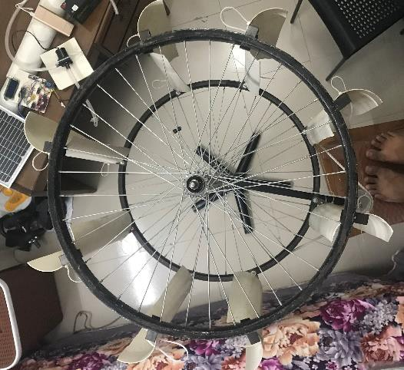 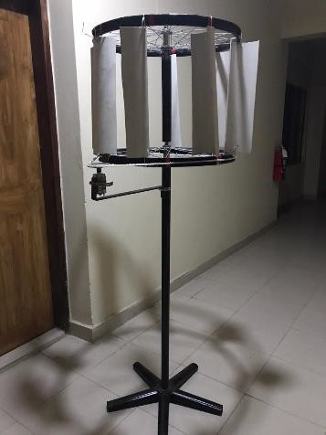

Figure 4.1 VAWT

In this project, two types of renewable sources were used one is VAWT and the other one is PV panel or solar panel. In VAWT PVC pipe, tie clamp, rubber, MS pipe has been used. 8 pieces of 30.48cm PVC pipe were taken and cut vertically into two pieces. After that, two cycle rims were taken and 16 steel anglers were attached with them. After that PVC pipe was attached and shaped as a vertical axis fan. By attaching GI pipe with one of the rims turbine stand was made. To check VAWT was working smoothly or not a light and a multi-meter was attached.

* + - 1. **Charge controller circuit**

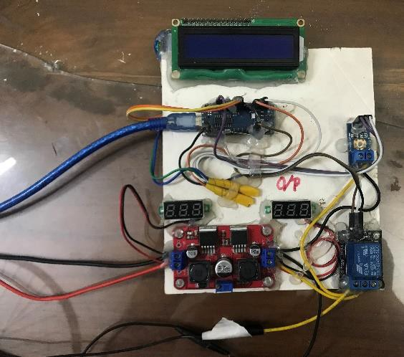

Figure 4.2 Charge controller circuit

MPPT (maximum power point tracking) charge controller circuits were used for this project. In this charge controller circuit Arduino Nano has been used because of its tiny size and functionality though its small but its working principle is as same as Arduino Uno. On the other hand, two displays (I /p, O/p) for voltage, I2C display, voltage sensor, relay module was used for the making. Arduino Nano was connected to 16*2 display. It was also connected to voltage sensor and relay module. To start the charge controller 4V is needed. In this project charge controller circuit prevents overcharging which affects battery life. Arduino Nano has been used for command.

* + - 1. **DC water pumping system**

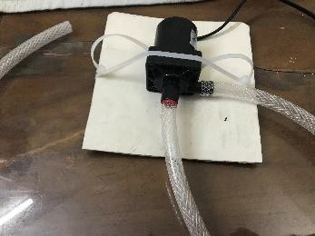 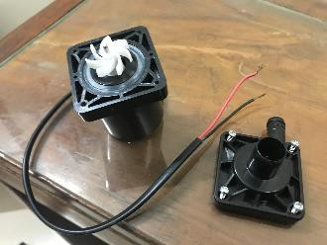

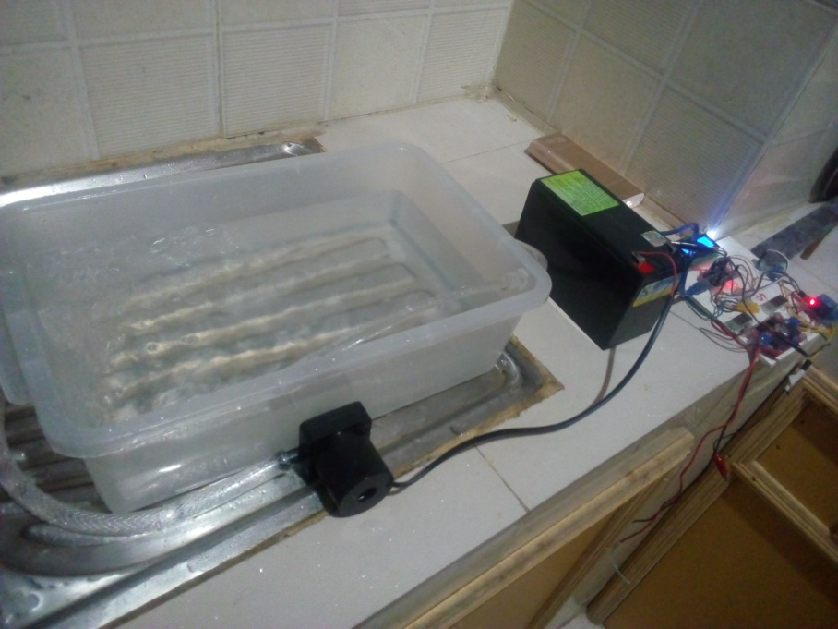

Figure 4.3 DC water pump

To make this water pump, 50cm input pipe and 100cm output pipe were used. It has 12V DC voltage and approximately 0.67A current capacity. As the water pump ran 30 minutes, so total power consumption is 14,400watt whether it has 8watt power.

* + 1. Market purchased equipment
       1. **Solar panel or PV panel.**

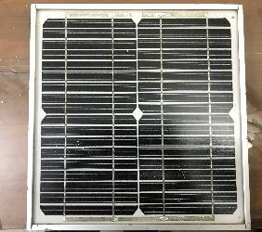

Figure 4.4 Solar panel

The using solar panel has maximum power point voltage and current was 17-30V and 0.44A consecutively. Moreover, its maximum power is 7.5 watt.

* + - 1. **Battery bank**

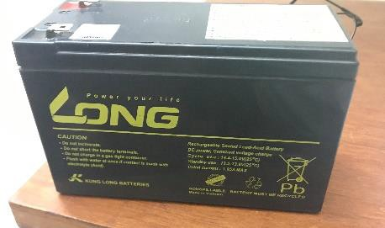

Figure 4.5 Battery bank

A 12V DC battery has been used to store the power initiated by the system. Beside this, it has 86.4watt maximum power and 7.2A maximum current.

* 1. Experimental setup (Hardware implementation)
     1. Design prototype of wind turbine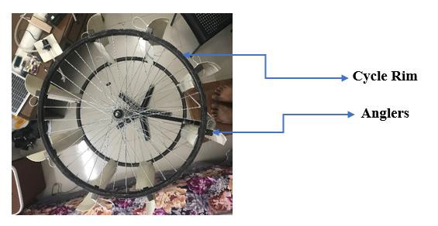

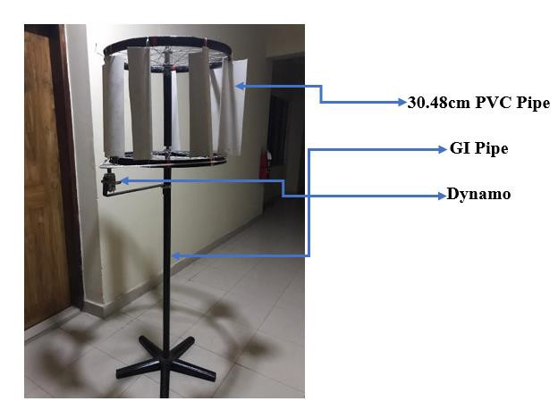

Figure 4.6 Prototype design of a Vertical Axis Turbine (VAWT)

In this project Vertical Axis Wind Turbine has been used. Vertical axis wind turbine will rotate with the help of wind and it will rotate the generator which will produce electricity. This produced electricity is used to run the designed pump. VAWT is much more efficient than other turbines but still they are not common for wider use.

* + 1. Design prototype of charge controller

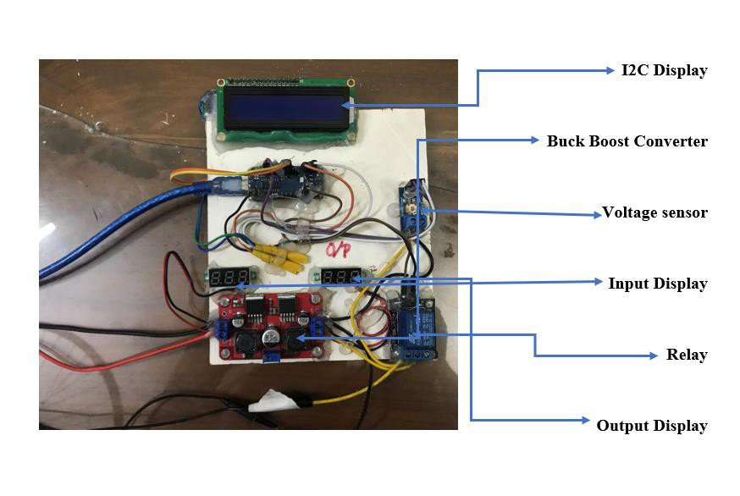

Figure 4.7 Prototype design of a charge controller

Charge Controller Circuit basically used for limiting the current for saving the battery life. It limiting the excessive current from the sources and passes the amount required for the battery bank. Then the battery bank stores the voltage.

* + 1. Design prototype of whole project

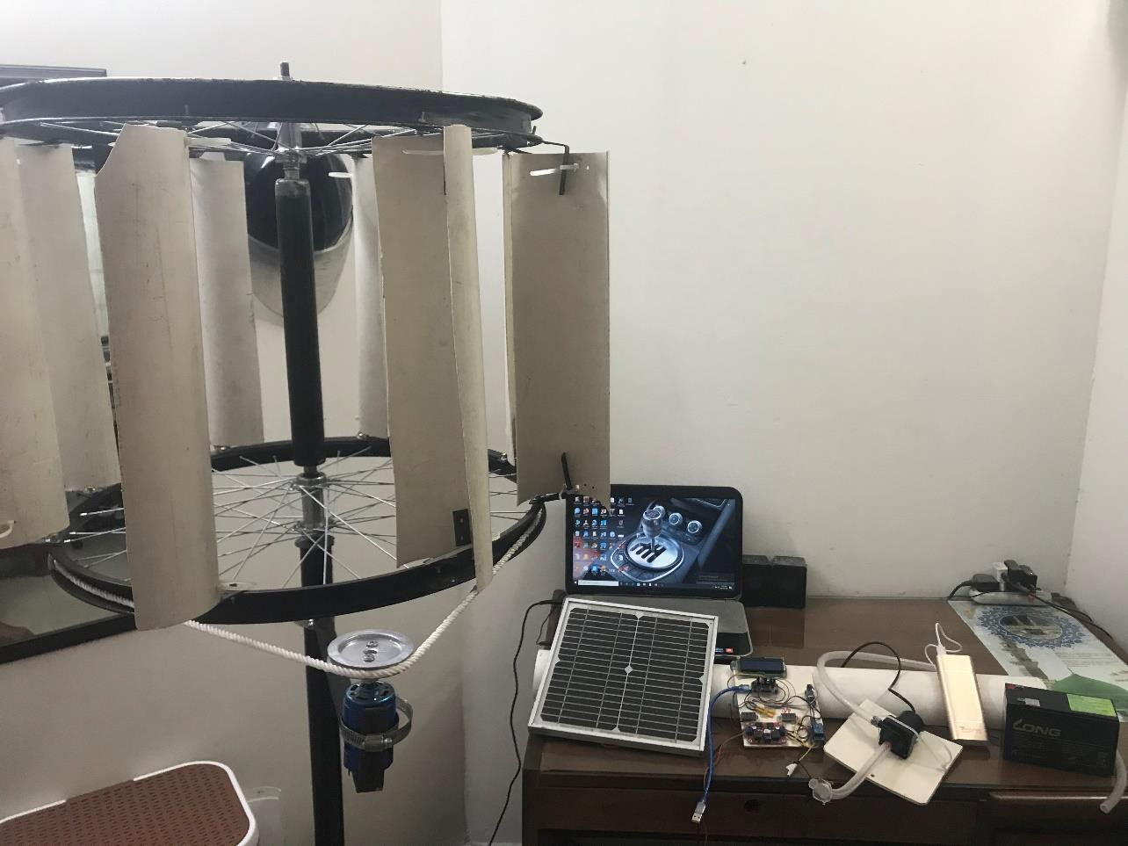

Figure 4.8: Prototype design of whole project

The given figure 4.8 shows the prototype of the whole project. On this project solar panel and wind turbine were connected parallel to the charge controller. Charge controller’s application is to reduce or control the excessive amount of current and pass the required amount of power to the battery bank to store it. From battery bank to turn on the DC water pump system it has been used when it’s needed.

* 1. Simulation of charge controller circuit

For simulation to check the efficiency of charge controller Simulink software has been used. Also, for the circuit diagram the same Simulink software was used.

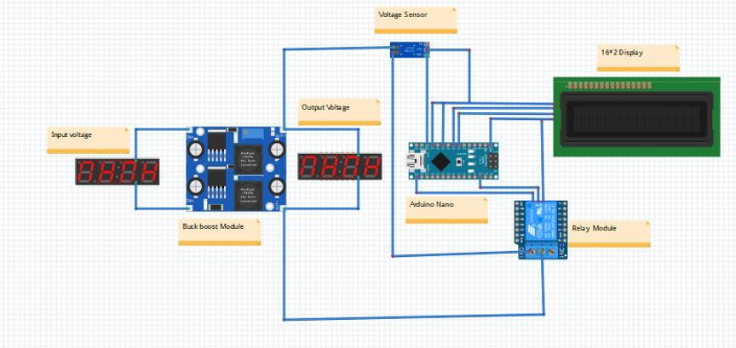

Figure 4.9: Circuit diagram of Charge Controller

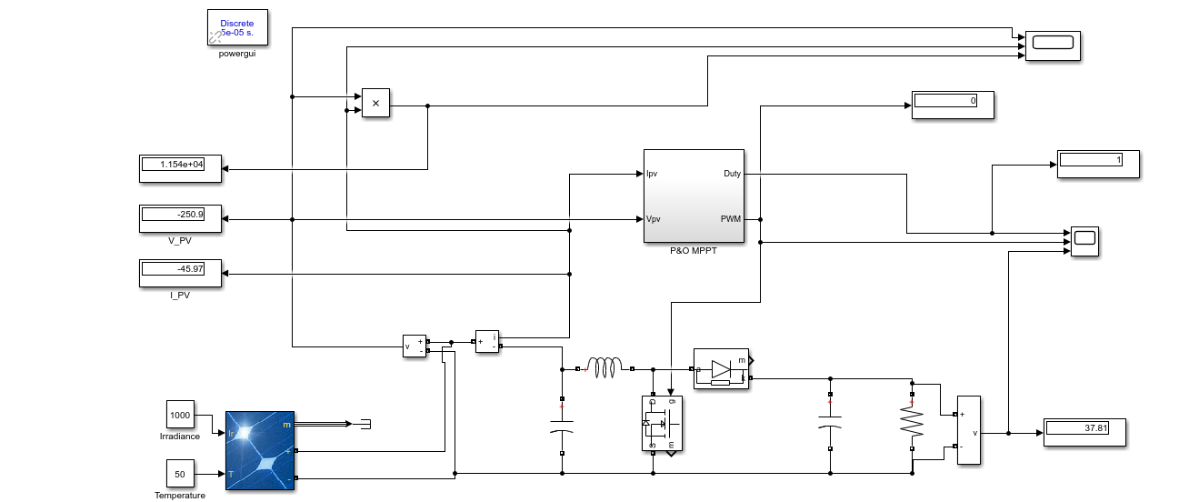Figure 4.10: Simulation of Charge Controller

* 1. Summary

The figure 4.8 shows at a glance of the project of hybrid renewable energy system based water pumping system where two renewable sources are connected parallel with the charge controllers. This project can initiate more power if the two renewable sources are working together. This chapter briefly discusses the setup of hardware implementation. Moreover, this project doesn’t use any dangerous equipment or chemical which is not eco-friendly.

Chapter 5

RESULT ANALYSIS AND CRITICAL DESIGN REVIEW

1. Introduction

The main purpose of this project is to build a water pumping system using hybrid renewable system. Hybrid renewable system is a type of system where more than one renewable source is used. In this project wind turbine and solar panel has been used to produce power. The produced power has been stored in a battery and used when it is needed. This chapter will show the result analysis and critical design review of the whole project.

1. Overall Outcome of the project

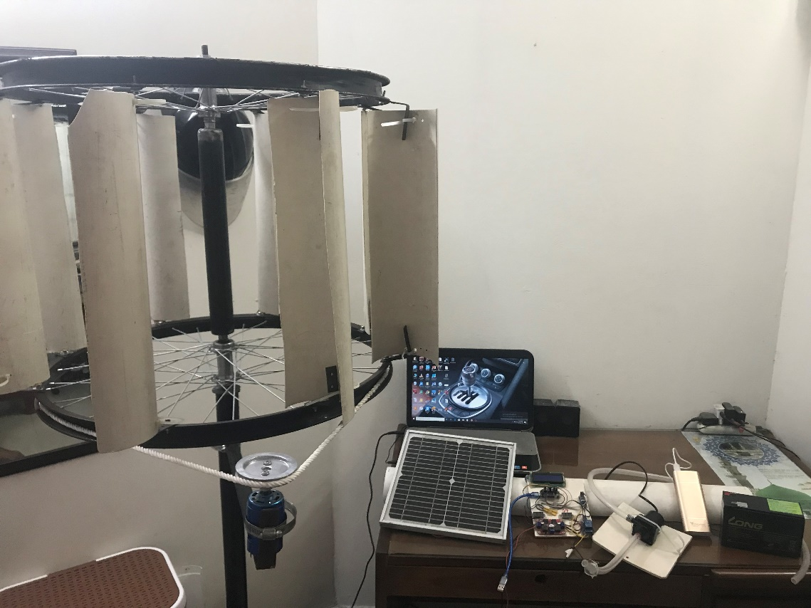

One 12-volt battery

Wind turbine

Solar panel

Miniature water pump

Charge controller circuit

Figure 5.1 Prototype design of the whole project

In this project, solar panel and wind turbine are connected to charge controller where charge controller controls the overflow of current and required amount passes to the battery bank. Then the battery bank runs the DC water pump.

1. Outcome of designed wind turbine

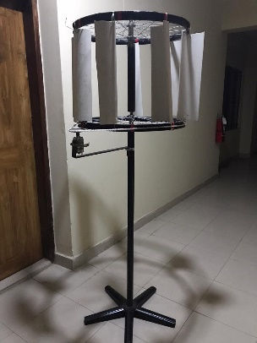

Figure 5.2 Vertical axis wind turbine

In chapter 4 the hardware implementation is elaborately discussed. In initial stage without the gearbox the output was measured. The table is given below:

Table 5.1 Initial stage without gearbox

|  |  |  |  |  |
| --- | --- | --- | --- | --- |
| Input rpm  (wind given to the turbine) | Received rpm  (wind power received by the turbine) | Output Voltage(V) | Output Current (amp.) | Power (watt) |
| 6675 | 303 | 1.09 | 0.11 | 0.1199 |
| 6955 | 364 | 1.15 | 0.14 | 0.021 |
| 7556 | 388 | 1.23 | 0.18 | 0.0414 |
| 7740 | 423 | 1.38 | 0.29 | 0.1102 |
| 8009 | 475 | 1.65 | 0.44 | 0.286 |

After adding the gearbox, the wind turbines output was measured. The table is given below:

Table 5.2 Initial stage with gearbox

|  |  |  |  |  |
| --- | --- | --- | --- | --- |
| Input rpm  (wind given to the turbine) | Received rpm  (wind power received by the turbine) | Output Voltage(V) | Output Current (amp.) | Power (watt) |
| 6217 | 345 | 1.21 | 0.75 | 0.91 |
| 6842 | 392 | 1.29 | 0.95 | 1.23 |
| 7780 | 425 | 1.33 | 1.01 | 1.34 |
| 8010 | 501 | 1.58 | 1.09 | 1.72 |
| 8559 | 565 | 1.73 | 1.17 | 2.02 |

1. Analysis of experimental wave shapes

The project output has been taken from the battery bank before it was connected to the DC water pump. The battery bank has been charged once through the solar panel and once through the vertical axis wind turbine (VAWT).

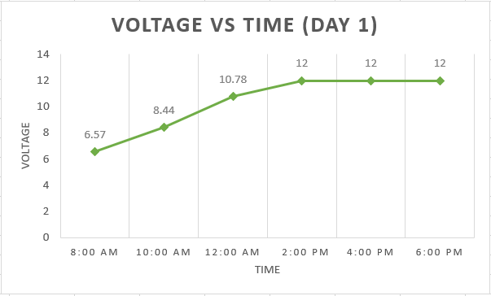

Figure 5.3 Battery charging time of first day by using solar panel (while battery is being discharged deeply)

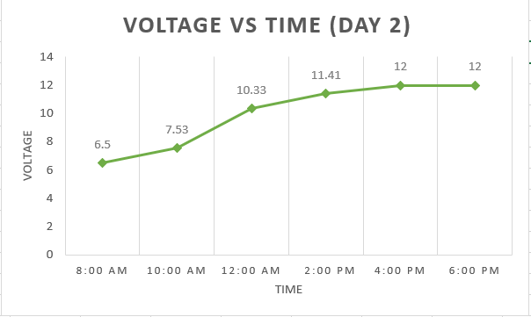

Figure 5.4: Battery charging time of second day by using solar panel (while battery is being discharged deeply)

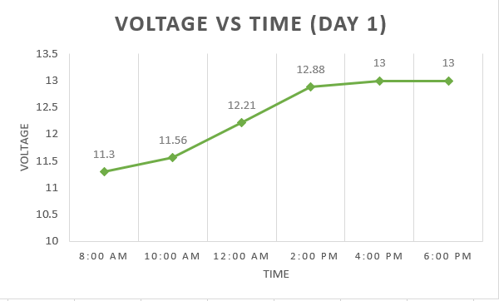

Figure 5.5: Battery charging time battery of first day by using wind turbine (when battery was not deeply discharged)

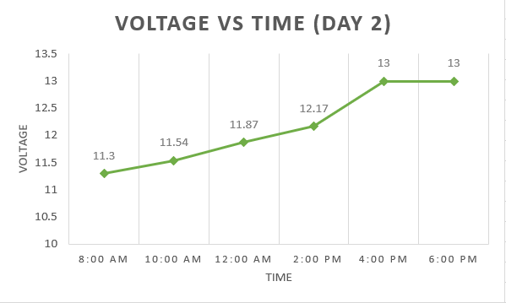

Figure 5.6 Battery charging time battery of second day by using wind turbine (when battery was not deeply discharged)

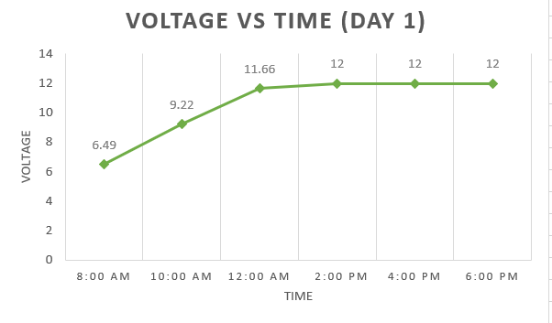

Figure 5.7 Charging battery by using both solar panel and wind turbine (first day)

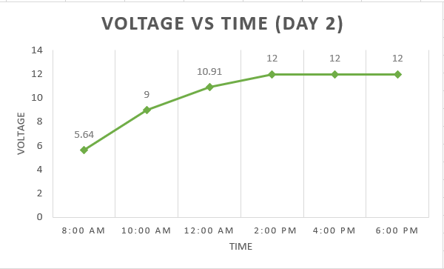

Figure 5.8 Charging battery by using both solar panel and wind turbine (second day)

1. Profound calculation of project output

Specifications of the battery:

Voltage: 12v

Current: 7.2v

Power: (12*7.2)

=86.4watt (max)

Water pump:

Voltage: 12v

Current: 0.67v

Power: (12*0.67)

=8watt

Solar panel:

Voltage: (Open circuit voltage: 21.70v, maximum power point voltage: 17.30v)

Current: (Short circuit current: 0.65amp, maximum power point current: 0.44A)

Power: 7.5watt (max)

In this project the pump ran 30 minutes, so total energy consumption by the pump is,

=Power of the pump*time

=8*1800 (joule)

=14,400 (joule)

From the demonstration it is found that the water pump can draw in total 35litres of water in 30 minutes, that means it is drawing (350/30) =11.67 liters (approx.) of water per minute.

1. Summary

This chapter has shown result review and critical design review of the whole project. The completion path of the project faced several obstacles, as a result expected outcome were not obtaining. Overheating of the motor was one of them. However, the key goal of the whole project was attained finally.

Chapter 6

CONCLUSION

## **Summary of findings**

The project is hybrid renewable system water pumping system. The main purpose of this was to make a water pumping system which is run by hybrid renewable system. This chapter shows the conclusion part of the whole project. All the costs and information are given in this chapter.

## **Project finance**

In this project, a prototype system has been designed. The following table shows the costs of the projects components:

Table 6.1 Project finance

|  |  |  |
| --- | --- | --- |
| Component | Quantity | Price (tk) |
| Solar Panel | 1 | 800 |
| Water Pump | 1 | 550 |
| Battery | 1 | 800 |
| 26" Cycle Rim | 2 | 800 |
| MS Pipe | 5ft | 250 |
| Turbine Stand | 1 | 400 |
| PVC Pipe | 6ft | 180 |
| Tie Clip | 16 | 80 |
| L shaped Clamp (small) | 16 | 640 |
| L shaped Clamp (large) | 1 | 60 |
| Rope | 4ft | 40 |
| Tie Clamp | 2 | 80 |
| Motor | 1 | 500 |
| Screw with bolt | 16 | 48 |
| Wire | 7ft | 70 |
| Arduino nano | 1 | 320 |
| Buck boost converter | 1 | 385 |
| Voltage sensor | 1 | 80 |
| Display | 2 | 80 |
| I2C | 1 | 135 |
| Relay | 1 | 70 |
| Total Cost | - | 6368tk |

## **Novelty of the work**

This project focuses to reduce power from power grid which emits lots of carbon dioxide, Ozone etc. Renewable sources don’t emit this chemical thing on the contrary its useful for life time. We know that this project exists but this project is unique for some reasons. One reason is, in this project we use VAWT with gear which will give more power.

Second reason is existing projects doesn’t use charge controller. But in this project charge controller has been used for limiting the excessive amount of power. Thirdly, those sources were used in parallel because if one source is unavailable or damaged then other sources work successfully to run the water pump.

## **Final impact of this project**

It is known that Bangladesh is a developing country. Power production is very limited here. So the whole country does not get enough electricity. Still electricity couldn’t reach rural areas in our country. This project can be very suitable for those rural areas and it can also be used in urban areas.

* + 1. Survey on environmental impact

On this project a survey has been done to get knowledge about the environmental impact. The survey was conducted by 30 people. Among 30 people 27% disagrees with system, 73% strongly agreed with the system because of its beneficial. Some could not respond because probably they didn’t understand the whole system or maybe they didn’t want the system.

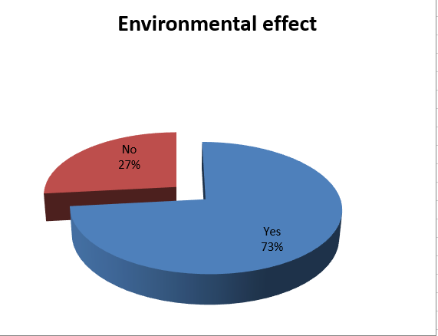

Figure 6.1 Pie chart of environmental effect

* + 1. Project sustainability and future scopes

This project is very suitable for any house. It has been planned that this projects design can be updated to a simple design in future. Light weight components can be used to lighten the whole project so that implementation of the whole project can be easier. In future renewable sources will be used all around the world.

* + 1. Recommendations on future developments

In future advance level of techniques will come also its features also. We will add these features in our system. We also add three or more renewable system to run this system. Also, automatic pump controller can be used. It will decrease the wastage of water.

* 1. **Limitation of the work**

Based on the proposed idea a prototype design has been implemented. Real life implementation was not possible because of limited time and resources. The price was also not justified in practical due to time limitation. Besides, whenever two 12V batteries were used the whole project got heated up. In this project charge controller is highly sensitive component because of its complex connection. If one of the connection is displaced the whole project won’t work. Otherwise, it works successfully.

* 1. Ethical concerns

In this project, our main purpose is to design a water pumping system by hybrid renewable sources. Though this project already exists but we used our own techniques. We used vertical axis wind turbine (VAWT) where another researcher was using horizontal axis wind turbine (HAWT). When we were testing our project there is not too much wind. That’s why the turbine was not running smoothly so for better performance, we used gearbox for getting maximum result. Also, without informing anyone we didn’t do the project.

* 1. Conclusion

The main purpose of making this project was to produce electricity without spending a lot of money and also in an eco-friendly way. A water pump cannot be run if there is no electricity. Rural areas in our country don’t get much electricity that can be good for running water pump. But rural areas does get enough sunlight and wind which can be good for running a renewable system and producing power to run a pump. That’s why this project is very suitable for the people living in rural areas and urban areas at the same time. People can buy this project at a cheap price and use it almost for free. There will be less waste of money and also there won’t be any environment pollution.

REFERENCES

[1] History of wind power; Available at: <https://en.wikipedia.org/wiki/History_of_wind_power>

[2] HAWT and VAWTs in operation large.gif; Available at: https://commons.wikimedia.org/wiki/File:HAWT_and_VAWTs_in_operation_large.gif

[3] Perspective for Fiber-Hybrid Composites in Wind Energy Applications; Available at: <https://www.mdpi.com/1996-1944/10/11/1281/xml>

[4] Horizontal axis wind turbine working principle; Available at: [http://electricalacademia.com/renewable-energy/horizontal-axis-wind-turbine-hawt-working-principle-](http://electricalacademia.com/renewable-energy/horizontal-axis-wind-turbine-hawt-working-principle-single-blade-two-blade-three-blade-wind-turbine/)  [single-blade-two-blade-three-blade-wind-turbine/](http://electricalacademia.com/renewable-energy/horizontal-axis-wind-turbine-hawt-working-principle-single-blade-two-blade-three-blade-wind-turbine/)

[5] Savonius wind turbine; Available at: [https://mechaniclove.com/wind-turbine-types/main-qimg-](https://mechaniclove.com/wind-turbine-types/main-qimg-94635f1f0ea3aa06995be51f04c4e43a-c/)  [94635f1f0ea3aa06995be51f04c4e43a-c/](https://mechaniclove.com/wind-turbine-types/main-qimg-94635f1f0ea3aa06995be51f04c4e43a-c/)

[6] Vertical axis wind turbine; Available at: [http://www.anthropocenemagazine.org/vertical-axis-wind-](http://www.anthropocenemagazine.org/vertical-axis-wind-turbine-2/?lang=es)  [turbine-2/?lang=es](http://www.anthropocenemagazine.org/vertical-axis-wind-turbine-2/?lang=es)

[7] Innogy starts construction of Australia’s largest solar plant; Available at: [https://www.constructionglobal.com/sustainability/innogy-starts-construction-australias-largest-solar-](https://www.constructionglobal.com/sustainability/innogy-starts-construction-australias-largest-solar-plant)  [plant](https://www.constructionglobal.com/sustainability/innogy-starts-construction-australias-largest-solar-plant)

[8] First hybrid wind and solar farm built in Australia; Available at: <http://www.climateaction.org/news/first_hybrid_wind_and_solar_farm_built_in_australia>

[9] Saudi eyes 30 solar, wind project in US$50; Available at: [http://www.eog-asia.com/saudi-eyes-30-](http://www.eog-asia.com/saudi-eyes-30-solar-wind-projects-in-us50-bn-renewable-energy-program/?fbclid=IwAR0YnMmI6EKVCEdhqRv3A0chEIRxG4JZ7BPZVJFfFry68sqogNu3eGVIDc4)  [solar-wind-projects-in-us50-bn-renewable-energy-](http://www.eog-asia.com/saudi-eyes-30-solar-wind-projects-in-us50-bn-renewable-energy-program/?fbclid=IwAR0YnMmI6EKVCEdhqRv3A0chEIRxG4JZ7BPZVJFfFry68sqogNu3eGVIDc4)  [program/?fbclid=IwAR0YnMmI6EKVCEdhqRv3A0chEIRxG4JZ7BPZVJFfFry68sqogNu3eGVIDc4](http://www.eog-asia.com/saudi-eyes-30-solar-wind-projects-in-us50-bn-renewable-energy-program/?fbclid=IwAR0YnMmI6EKVCEdhqRv3A0chEIRxG4JZ7BPZVJFfFry68sqogNu3eGVIDc4)

[10] USA’s first solar-wind hybrid power project; Available at: [https://www.energymatters.com.au/renewable-news/solar-wind-hybrid-em5928/?fbclid=IwAR0Swd-](https://www.energymatters.com.au/renewable-news/solar-wind-hybrid-em5928/?fbclid=IwAR0Swd-v7gPI0S5Zif8kakaGqR4PnbByH9xo14Dpt_AVurHzi5D98BnrEfo)  [v7gPI0S5Zif8kakaGqR4PnbByH9xo14Dpt_AVurHzi5D98BnrEfo](https://www.energymatters.com.au/renewable-news/solar-wind-hybrid-em5928/?fbclid=IwAR0Swd-v7gPI0S5Zif8kakaGqR4PnbByH9xo14Dpt_AVurHzi5D98BnrEfo)

[11] JUWI wind and solar plant in Egypt is remote-controlled from Germany; Available at: [https://www.greenprophet.com/2012/11/remote-controlled-juwi-wind-solar-](https://www.greenprophet.com/2012/11/remote-controlled-juwi-wind-solar-egypt/?fbclid=IwAR1lHbHa2S8coSeEcTHrACr7LuEkTP4i_6BqojOT3TA9oZ0evQ1s9xJdXYs)  [egypt/?fbclid=IwAR1lHbHa2S8coSeEcTHrACr7LuEkTP4i_6BqojOT3TA9oZ0evQ1s9xJdXYs](https://www.greenprophet.com/2012/11/remote-controlled-juwi-wind-solar-egypt/?fbclid=IwAR1lHbHa2S8coSeEcTHrACr7LuEkTP4i_6BqojOT3TA9oZ0evQ1s9xJdXYs)

[12] The history of pumps; Available at: [http://www.sintechpumps.com/history-of-](http://www.sintechpumps.com/history-of-pumps/?fbclid=IwAR06r8v3Oxi9lMR2vzOLUKMnjWiAqGxFv9x5lanW-ssjYpnQLs0P90gJpUs)  [pumps/?fbclid=IwAR06r8v3Oxi9lMR2vzOLUKMnjWiAqGxFv9x5lanW-ssjYpnQLs0P90gJpUs](http://www.sintechpumps.com/history-of-pumps/?fbclid=IwAR06r8v3Oxi9lMR2vzOLUKMnjWiAqGxFv9x5lanW-ssjYpnQLs0P90gJpUs)

[13] Timeline of solar cells; Available at: <https://en.wikipedia.org/wiki/Timeline_of_solar_cells>

[14] 60 years ago Bell Labs unveiled the solar cell; Available at: <https://www.gizmodo.com.au/2014/04/60-years-ago-today-bell-labs-unveiled-the-solar-cell/>

[15] People have been using wind energy for thousands of years; Available at:

<https://www.eia.gov/energyexplained/index.php?page=wind_history>

[16]<https://www.researchgate.net/publication/306047475_Electric_Energy_Access_in_Bangladesh>

[17] <https://www.dhakatribune.com/bangladesh/power-energy/2019/01/12/can-bangladesh-meet-its-10-renewable-energy-target-by-2020>

Appendix A

Survey Questionnaire

* Survey questionnaire on societal impact:

1. Do you think our project can be environmental friendly?

= YES / NO

2. Do you think our project can be useful for everyone?

= YES / NO

3. Do you think this project can be bought at low cost?

= YES / NO

4. Would wind and solar energy solve your energy problem?

= YES / NO

5. Do you think this project can be used in your area?

= YES / NO

6. Do you think people can be benefited by the project we are making?

= YES/ NO

7. Would you use it in your house and farm to get water?

= YES/ NO

8. If we successfully make the project would you buy it?

= YES / NO

* Survey questionnaire on environmental impact:

1. Do you think this project can be environmental friendly?

= YES / NO

2. Do you think this project can be good for greenhouse effect?

= YES / NO

3. Do you think this project will emit Carbon Dioxide?

= YES / NO

4. Do you think this project will produce heat?

= YES / NO

5. Do you think this project will need any fossil fuel?

= YES / NO

6. Do you think this project will pollute air?

= YES/ NO

7. Would you use it in your house and farm to get water?

= YES/ NO

8. Do you think the water of the pump will be safe to use?

= YES / NO

9. Do you think this project will pollute water?

= YES / NO

10. Do you think this project will be safe to implement?

= YES / NO